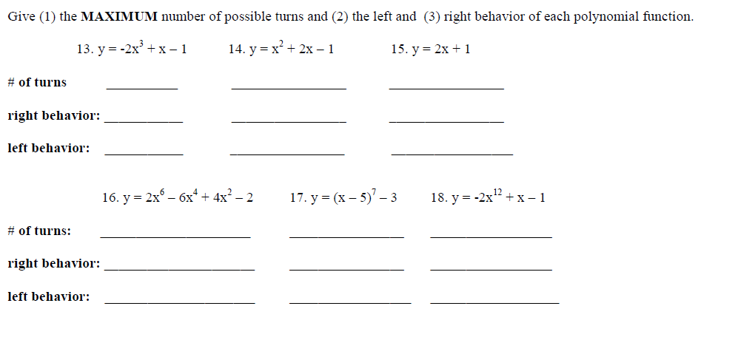

3

2

1

6

5

4



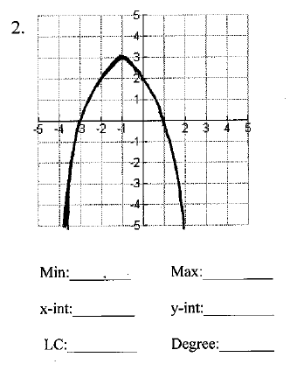

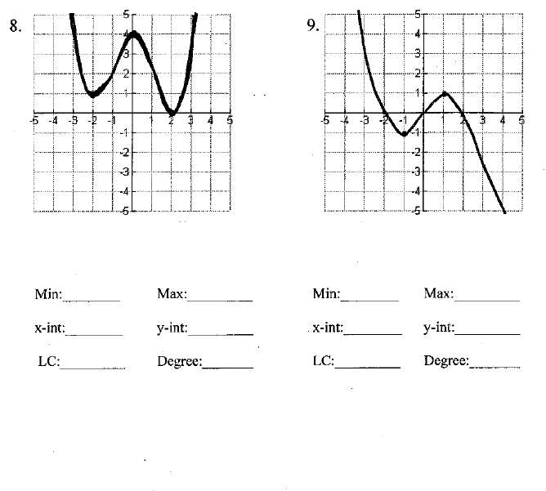

7

Find the domain and range of each graph. (write your answer in **interval** notation)

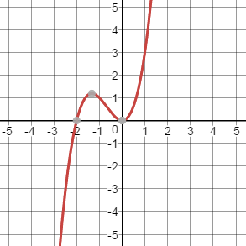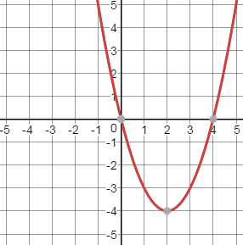10. 11.

Domain:___________________ Domain:___________________

Range:____________________ Range:____________________

Given the following function, use the remainder theorem to find the value.

12. $f\left(x\right)= -2x^{3}+4x^{2}-6x+1$

a.) $f(-1)$ b.) $f(0)$ c.) $f(2)$

Determine whether the given x-value is a zero of the given function.

13. $x^{4}-{8x}^{3}+10x^{2}+2x+4, x=2$

14. $x^{5}-{25x}^{3}-7x^{2}-37x-18, x=-5$

Given the following function

a.)find the discriminant

b.)find the number and types of zeros

c.) find all zeros of the function (real and imaginary) given one real root.

15. , x = 2 16. , x = -4

Given the following function

a.)find the discriminant

b.)find the number and types of zeros

c.) find all zeros of the function (real and imaginary) given the graph

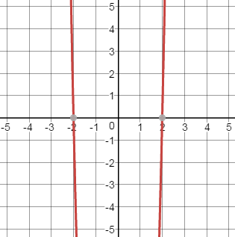17. 